Reading
Kieran Prior: Goldman Sachs’s whizz-kid wheeler dealer
Working on the noisy, frenetic trading desk at Goldman Sachs's London offices on Fleet Street earlier this decade, Kieran Prior and John Yeatts, two bright and ambitious twentysomethings from very different worlds, became close friends.
Although Prior, then 23, was just a year older than Yeatts when they met, he enjoyed giving practical advice, teasing the American about his Saturday-night dates. Yeatts returned the favour. When traders ordered lunch delivered to their desks, Yeatts cut up Prior's food and fed him one small bite at a time. Prior was born with a rare condition that affects his movement and impairs his speech. He cannot get out of his wheelchair unaided, and has never been able to walk.
Yet despite these physical limitations, Prior is thriving on Goldman's trading desk possibly the most demanding and competitive testing ground in finance - winning the admiration of colleagues while gaining experience, confidence and responsibility.
It's not easy managing investments of any size for the high-powered trading machine that supplies much of the earnings of Wall Street's most profitable firm. It is extraordinary that Prior is able to do so with such physical limitations.
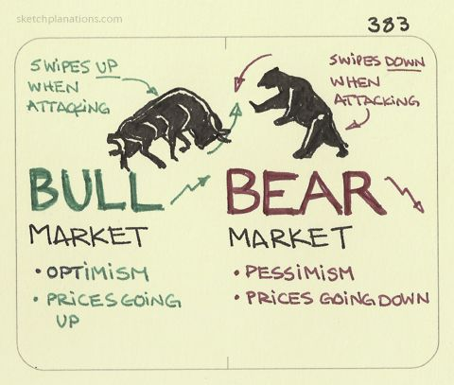
Gary Williams, the former head of European equity trading, who hired Prior nearly eight years ago, has enormous respect for his determination. 'He is an exceptionally smart, perceptive guy who has purposefully risen to - and overcome - so many challenges.' said Williams. 'The noise and hurly-burly of the trading floor make trading more difficult for someone in Kieran's position, but the challenge actually appeals to him.'
Intellectually, Prior, now 29, has few limits. Since joining Goldman as a financial analyst in the equity division in 2000, Prior - whose IQ score of 238 puts him in the top I% of the world's population - has risen from performing basic research analysis and trading Euro Stoxx futures to running a $50m (£25m) group of European equities and derivatives.
Prior joined Goldman just four days after he graduated from university. Early on, he caught the attention of John Thornton, Goldman's then-president, as Thornton was walking across the trading floor. Thornton stopped for a brief chat - and was amazed.
'I couldn't help but be impressed,' said Thornton. 'First of all, Kieran's sheer, raw talent is impressive, and when you add to that the determination he shows getting through the day in a place like Goldman Sachs, which is so demanding, it is just breathtaking.
Prior is free to invest in almost any business sector, but recently narrowed his focus to just 20 companies because of the extreme volatility in the markets. 'I joined Goldman in a bear market; he said, 'but these markets are the most difficult I've ever seen, so I ‘m just using this period of volatility to learn as much as I can.'

A. Read the article and complete the profile:
Name: Kieran Prior
Age:
Job:
Duties:
Company:
Work location:
IQ:
Personality/Strengths:
Current area of specialisation:

B. What is the difference between a Bull market and a Bear market?

C. Match the following definitions to the bold words in the text.
Example: financial analyst = Someone who carefully examines the financial state of a company.
- A financial market in which prices are falling.
- People who deal in shares and bonds.
- Sudden and quick change.
- The area of a financial market where a particular market does business.
- The careful examination of the performance of companies and stocks.
- The profit that a company makes in a particular period of time.

